Heuristic Evaluation of Booking Widget / Booking Engine
Definitions
Booking Widget – the affordances on the resort pages and on AMR Collection that sends the user to the Booking Engine.
Booking Engine – the website and system that allows the user to book a resort room for specified days.
Sight Structure and Page Mapping
In order to facilitate discussion, the following site map will be used in this document. Where specific views are cited, this will be your guide to the page in the actual booking site. 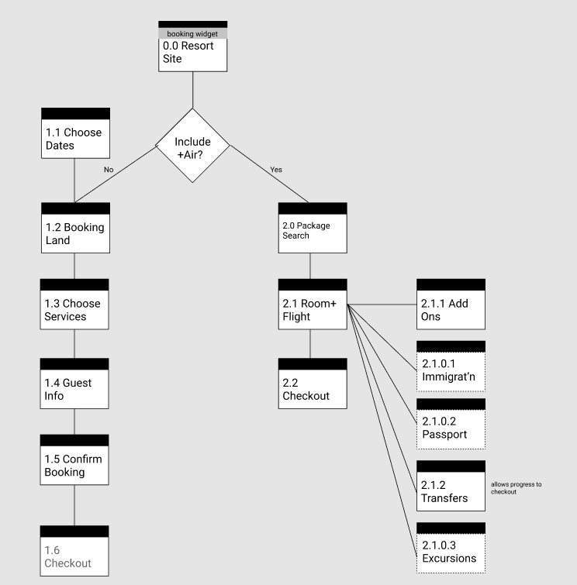

Issues
CRITICAL
Location: Between 1.5 Confirm Booking and 1.6 Checkout
On completion of the search and at the point of purchase, the system sent a small notice that the price had changed and the user had to begin a new search. This, more than any other problem is likely to have the biggest impact on successful purchases. User’s are already wary of price changes between selection and purchase, convinced that they are “being gouged.” Secondly, forcing the user to start again gives them a choice to either start again with AMR or to go elsewhere. Since the AMR system already failed them, they have an incentive to go elsewhere. Finally, the small notice is nearly unreadable and has so much normal context around it, it appears to be a system error rather than the system operating properly. The notice is not highlighted and doesn’t even offer a link to start a new search.
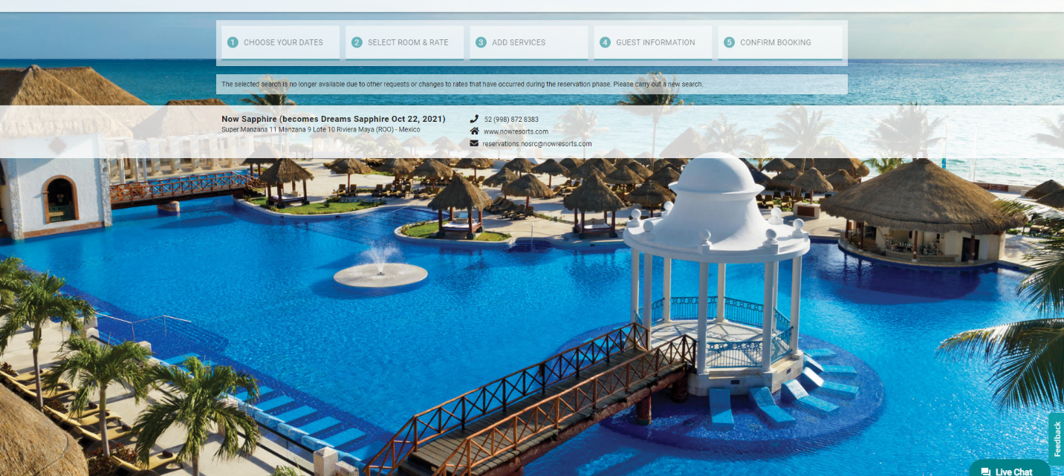
Possible Fixes:
Lock price for user once user selects resort/room type/days. This means prices at checkout for one user may be different than the going rate, but it eliminates the possibility of disappointment.
Explain the new price, why it changed, and give user an option to continue or cancel purchase.
Allow the user to save room selection with a notice that prices are not guaranteed until purchase.
Mark all prices as approximate until purchase time. This is probably the easiest solution, but does not remove the trust issue for the user.
Critical
Location: Booking Engine
The reservation checkout system seems to have mixed sections, with special services being on the payment page, extras being mixed in with flights etc. Research must be done to determine what information the typical user will want to complete now, which they might need to save for later, and which items they are unsure of and might want to complete at another time. The reservations should then be organized along those lines in carefully constructed, segmented, steps. Those steps should be recapped on every page, showing the progress they have made and what items need to be done. For example, the path could be “Resort > Room >Traveler Info > Air Choices (including seats, extras, FF Numbers, etc. > Transfer > Extras (including insurance) > Summary > Payment. Since this is a lot of information and work, the user must be able to pick it up and leave it at random, but not lose any work. They should be able to change any option they want until payment (with the understanding the price is not guaranteed until payment).
Critical
Location: Uncertain. Appears on 1.2 Booking Land
Multiple Itineraries shown on the left suggests that saving reservations is already technically feasible, it is just not exposed to the user unless they start a second itinerary. It is unclear how long these Itineraries are saved, what their limitations might be, or how you can share them. The “Retrieve Reservation” popup asks for a Reservation Number, but this doesn’t exist in the itineraries.
Solution – The saving feature must be exposed to the user and tools enhanced so the user can create, recall, edit, or delete itineraries. The lifespan and limitations of the itinerary should be spelled out for the user. These saved itineraries will be an excellent base for any future sharing feature.
Critical
Location: 2.1 Room + Flight
This page does not reiterate the currently selected flight unless the user chooses to ‘Change Flight’ and Returns to this page. Since one of the purposes of this page is to provide the user the opportunity to judge the suitability of the flight chosen, this is an obvious block to completion of the task.
Possible Fix: Show the currently selected flight, with details, to the user to let them determine if it is acceptable.
This may be a technical issue, but since it occurred multiple times, I believe it is a UX issue.
IMPORTANT
Location: 1.1 Choose Dates
If the user is sent from an almost completed transaction to a “New Search” as above, none of the criteria is reiterated when the user gets to the search. This makes sense, technically, because the user is given no tools to go from the massive disappointment of losing their previous work to a recoup of some of their work.
If the above Critical Error is fixed with just a link to a New Search, reiterate search terms in the search fields so the user’s work is not completely lost.
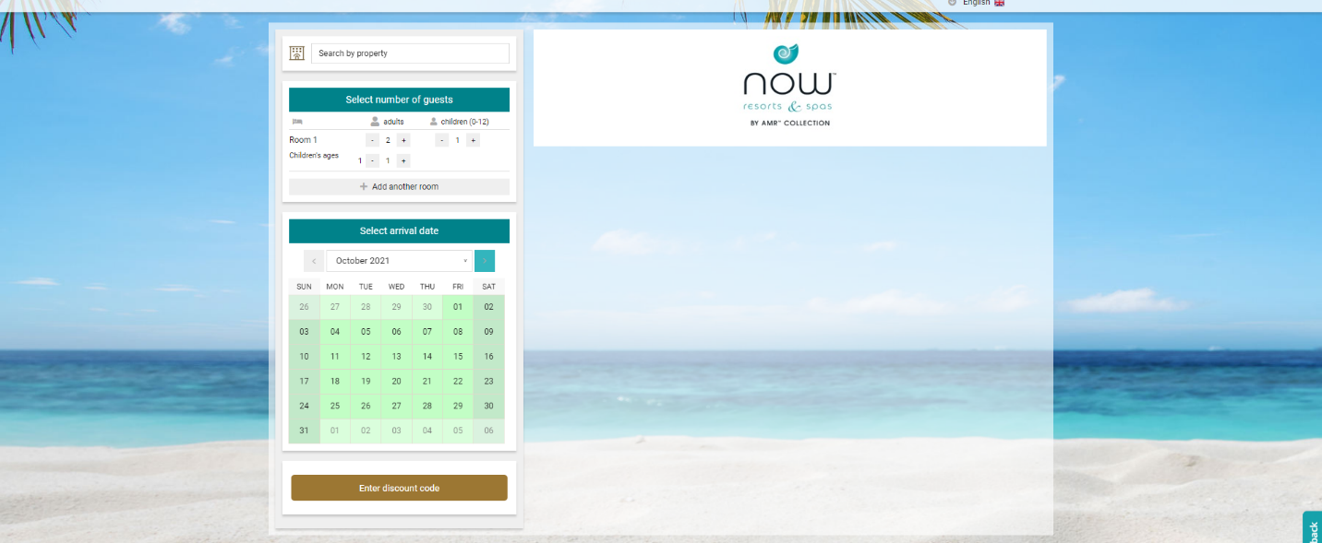

IMPORTANT
Location: All
There is no way to save progress and no social media option. Given the possibility that price will change and the user may be forced to restart, a ‘save’ option needs to be implemented. It would carry a number of caveats about availability, price fluctuations, etc.
Further, this would be an ideal place to allow for a social sharing element. An unknown number of vacationers need to coordinate with spouses, children, friends and family, so allowing a pause with an approximate price would facilitate that coordination. Short of sharable progress, the only option for coordination is to wait until all possible vacationers are in communication from the start of the search through to purchase.
Less Important
Location: 0.0 Resort Site
The booking widget has ‘false defaults’ as the first item in each dropdown is highlighted in ‘hover’ state. This should be removed.
Less Important
Location: 0.0 Resort Site
Booking widget affordances change size depending on user choice. Since this has no interpretable meaning, it should be removed.
Less Important
Location: from 0.0 Resort Site to 1.2 Choose Room/ Booking Land
Choices made prior to the Booking Engine are not consistently carried through as choices in the Booking Engine. For example, going from the “Mexico” page on AMR Collections does not pre-select Mexico as the desired destination.
IMPORTANT
Location: 1.1 Choose Dates
Change Search function does not seem to carry any information from the immediate preceding page. As a general rule, any information the user has entered should be retained and recapitulated until the user changes it. To do otherwise is to destroy user work, and to remove user sense of control.
Less Important
Location: 1.1 Choose Dates
Calendar animates in as the user chooses new dates. If the animation is giving the user some new information, it is useful. If it is not, if it is just decoration, it should be removed.
IMPORTANT
Location: 1.1 Choose Dates
Calendar functionality is mismatched. In the normal use of the calendar, following the common design on the web, the user selects a check in date and a check out date. This calendar asks for a check-in date and then the number of nights to stay. This should be tested and if it is more useful, kept and propagated through all web properties. If it not more useful, then the normal calendar function should be used.
Less Important
Location: 1.1 Choose Dates
The calendar widget has two different affordances for advancing months. One should be removed.
Cosmetic Issue
Location: 1.2 Booking Land through 1.5 Confirm Booking
Dates have a horizontal line through them in the Booking Engine. This is not explained to the user. It should be removed.
IMPORTANT
Location: 1.2 Booking Land
The search recapitulation is not editable. The edit function for a search is cumbersome, requiring what is in effect a new search.
Recommended fix – allow the user to increment/decrement all items (Adults, children, days, ) in situ rather than sending them to another view. If that proves uneconomic, allow the user to edit the numbers in a dialog box.
In the case of children’s ages, in situ incrementing is available, but using the tools causes the page to be refreshed at each press. Again, this should not be refreshing, if that is troublesome or uneconomic, a dialog box that submits the new numbers on close would suffice.
IMPORTANT
Location: 1.2 Booking Land
“Sort By” is visually, a button, but is functionally a dropdown. The short “Sort By”, the button “Price” and the options “Increasing” and “Decreasing” do eventually make sense, but require more user interpretation than a more standard implementation.
Cosmetic Issue
Location: 1.2 Booking Land
The pictures of the resorts are either the wrong size or disconnected from pictures that would give judgable information. Pictures, in general, should be sized so the user can see the detail needed to make a decision – stay at the resort. If that is impractical – as in this case – they should be linked to larger versions of the picture to let the user see the detail needed. In addition, a popup picture would be an excellent opportunity to introduce a gallery of resort photos to sell the user on the resort.
IMPORTANT
Location: 1.2 Booking Land
The listing of the rooms with prices per 2 pax are not clickable. While this does give the range of prices for the resort, it does so at the cost of a great deal of space. More common would be a line of text that says ‘from $xxxxx’ to give the user a general idea of the price.
A decision needs to be made here and it requires some user research. If the users typically choose resorts and then rooms, as currently modeled, this ‘teasing’ of room rates without deep linking them, is problematic. If, on the other hand, the user makes a more sweeping decision based on resort and room available, then this section could be expanded to allow the user to see / select resort and room together. As is, assuming the model of resort > room is correct, this detail listing of prices/room types is too early in the decision making process.
Less Important
Location: 1.2 Booking Land
Terms and Conditions should be a popup so it doesn’t interrupt the funnel to sale.
Less Important
Location: 1.2 Booking Land
“Select Room” is a label, but is styled like a button.
IMPORTANT
Location: 1.2 Booking land
Actual Select Room button is not visible unless user expands the resort section. This could easily be interpreted as the resort relying on phone reservations and online sales not existing. Select Room should be immediately visible.

Cosmetic Issue
Location: 1.2 Booking Land (popup)
Room image gallery has two separate control sets.
Less Important
Location: 1.2 Booking Land
The resorts in the booking engine have no gallery to sell the resort. The assumption that the user has already made a choice is not well grounded given the ‘random access’ of the web. In addition, the assumption the user will follow a pre-ordained path is constrictive when planning for social media – if we expect users to share resorts and/or trips, the site must be prepared to serve users with all mindsets – perfectly well informed or truly naïve.
Less Important
Location: 1.2 Booking Land
The resort info section includes Location and Map. Unless they show different information, they should be combined.

Less Important
Location: 1.2 Booking Land
What information is in the Rooms subsection of the resort info that is not in the multiple sections explaining each room in turn? If there is none, this subsection should be removed.
Less Important
Location: 1.2 Booking Land
The resorts move when hovered. While this may be considered a ‘nice trick,’ it is an annoyance when trying to hit a tiny button. If the animation had any connotation, it is lost on the user. This effect should be removed.
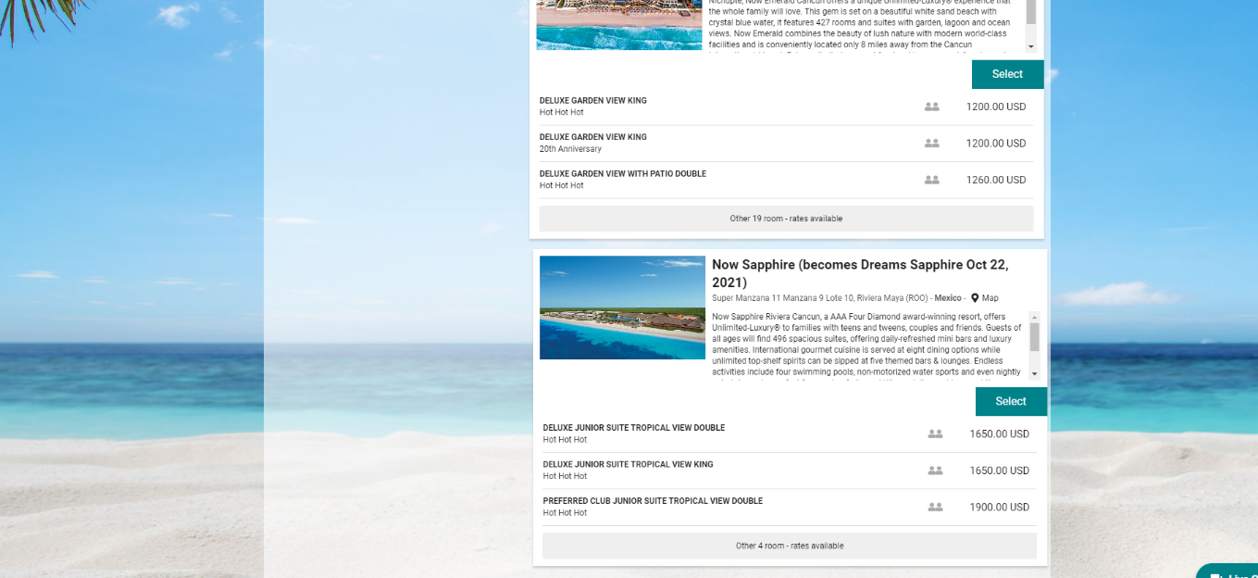
Important
Location: 1.3 Choose Services
The Continue button is disconnected from the information being interpreted. A secondary, “Continue without additional services” has the prime location, which works against the business interests of selling more services.
Combining the two buttons, or better, moving the Continue and recap to the top of the page should solve this issue, although further research and design is warranted.
Less Important
Location: 1.3 Choose Services
In checkout flow, the system often uses expansion boxes to show more information which in turn contain more expansion boxes, which don’t seem to serve any purpose.
Use expansion boxes and the resulting screen savings only when necessary. Hiding information from the user must be justified by showing them more overview information.
Cosmetic Issue
Location: 1.4 Guest Info
The box for entering the Frequent Flyer number for an airline only includes the airline being flown, not any of their partner airlines. This is a low priority fix.
Less Important
Location: 1.4 Guest Info
The TSA information is hidden behind an expansion box. Research should be done to determine if this is useful enough to the user to move up in the info hierarchy and outside of a collapse box.
Less Important
Location: 1.4 Guest Info
The “?” help items are included in the tabindex, forcing the user to pay attention when they may be trying to tab through the interface. In addition, the tip that is surfaced seems to move items around, breaking up any design alignment.
Less Important
Location: 1.4 Guest Info
The error messages make the fields move around, making it more difficult to acquire the fields and to associate the errors with the correct fields. Space for the errors should be row level, not individual level. Even better, the form should be single column, removing the problem of the form grid entirely.
IMPORTANT
Location: 1.4 Guest Info
The two column format for the form is working against usability. It leaves the user with Password on the right and Re-enter Password on the left. Forms should be single column, left aligned.
Less Important
Location: 1.4 Guest Info
The Airline Information section asks for email and phone number a second time. If this is required, add a ‘Same as above’ affordance so the user doesn’t have to type it twice. Ideally, it would just explain that it is sending your name, email and phone number from above with an opt-in checkbox.
Important
Location: 1.4 Guest Info
Frequent Flyer information should be an optional step after entering the basic traveler info for all travelers. Since that information is rarely at hand for all travelers, it should be something they can skip and come back to if/when they have the information.
Less Important
Location: 1.4 Guest Info
The form for Traveler Information asks for Mobile Number and Phone Number. This is confusing to people who have one phone number and don’t distinguish between mobile and non-mobile. If there is a specific reason to collect non-mobile phone numbers, remove any distinction between mobile and otherwise. Replace with Phone Number and Alternative Phone Number (optional).
Less Important
Location: 1.6 Checkout
The term “Payment Method” has become common to denote the area where the user chooses how to pay a bill. Using this term instead of Payment Policy or some other term is confusing.
Important
Location: 2.1 Room + Flight (popup)
Choosing a new flight seems haphazard, the details of each flight and the difference from what the user already dismissed is not explained. New flight options, for example, instead of being listed as total expense for the vacation, they could be listed as +$ or -$ from the current choice. If the user objects to the airline, the connecting stop, the length of layover, etc., tools to solve each of these needs should be provided.
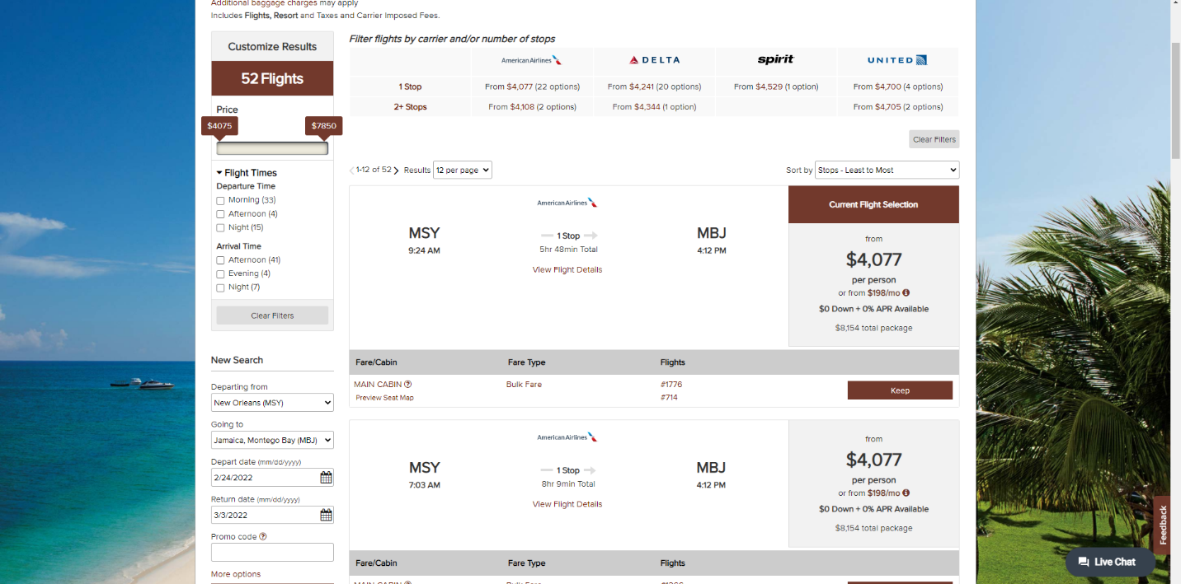
Cosmetic Issue
Location: Many
Consider bolding the data the user may be looking for instead of the label for the data.
Less Important
Location: 2.1 Room+Air
When the user chooses “Extras,” the page reloads. This should be done in screen whenever possible, using partial refreshes.
Important
Location: 2.2 Checkout
Password ‘rules’ are not shown until the user makes a mistake. “Gotcha” is not a design guideline.
Cosmetic Issue
Location: 2.0.2.2
In the popup for passport and other ID requirements, the “Highlight” section has all the information, but the “General” section is empty. The wording for the site needs to be checked as well, as the term “ID” is used when “Passport” is meant.
Less Important
Location: 2.1.0.x (unmapped)
Seat selection has a confusing UI, expecting the user to go to “Next” rather than “Save” to go to next flight.
Save button should be removed or deactivated until the user has completed all work.
Important
Location: 2.1.1 Add Ons
The Special Services dropdown does not allow for multiple selection, forcing the special case user to choose between, for example, non-smoking and handicap accessible, when they want non-smoking AND handicap accessible.

Less Important
Location: 2.1 Room+Flight
If possible, give the option to the user to do the extra services later and make sure they know it is not a ‘use it or loose it’ proposition.

Possible Technical Issues
Unknown Issue
Location: 1.1 Choose Dates
Broken views were seen while this review was being compiled. I do not know how often they happen or why they happen.
Unknown Issue
Location: Booking Engine
In more than one case the “i Details” link did not operate. I do not know how often or why this happened.
Unknown Issue
Location: 1.2 Booking Land
Property Info Box(es) seemed hit and miss. Sometimes they had info, often they were empty.
Unknown Temporary Issue
Location: Booking Widget, Booking Engine
The pages for Now Resorts say the resort will become the Dreams equivalent, but does nothing to allay any fears the user might have about the transition. The notice doesn’t even mention that Now and Dreams are the same company.

